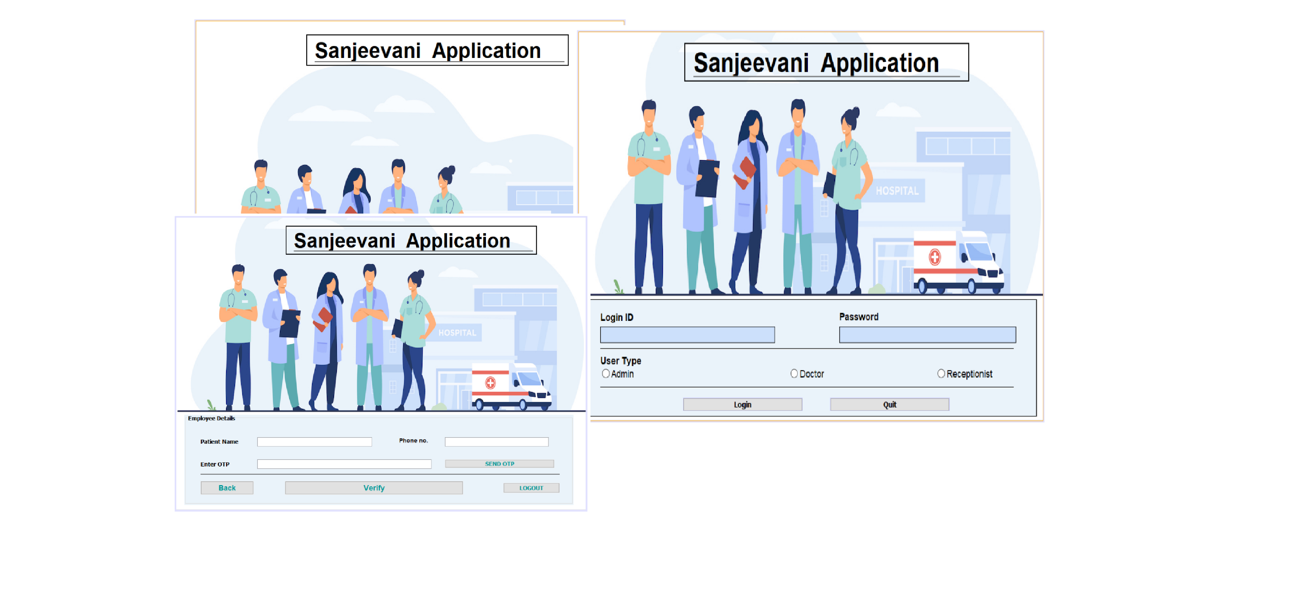

In this project, we have created a **Hospital Management System** application. Through this management system app, we can deal with the **management of the employees** working in the hospital in a much **simpler** way.

In this project, we have **three** different user interfaces, the **Admin** user interface, the **Receptionist** user interface and the **Doctor** user interface.

**The Admin User Interface :**

This user interface will deal with the management of the **receptionists** and **doctors** working in the hospital.

**The Receptionist User Interface :**

This user interface will deal with the management of the **patients**.

**The Doctor User Interface :**

This user interface will deal with the management of the **appointments** of the patients.

Over all , the project **“ Hospital Management System** ” , will have following frames :-

* **The Project contains 4 main module -**
  + Login Module
  + Admin Module
  + Receptionist Module
  + Doctor Module
* ***Login Module* -**
  + **SplashScreen**
  + **LoginFrame**
* ***Admin Module -***
  + **AdminOptionFrame**
  + **ManageEmployeesFrame**
  + **AddEmployeeFrame**
  + **UpdateEmployeeFrame**
  + **ViewEmployeeFrame**
  + **RemoveEmployeeFrame**
  + **ManageReceptionistsFrame**
  + **AddReceptionistFrame**
  + **UpdateReceptionistFrame**
  + **ViewReceptionistFrame**
  + **RemoveReceptionistFrame**
  + **ManageDoctorsFrame**
  + **AddDoctorFrame**
  + **ViewDoctorFrame**
  + **RemoveDoctorFrame**
  + **ViewPatientsFrame**
* ***Receptionist Module -***
  + **AddPatientFrame**
  + **UpdatePatientFrame**
  + **ViewPatientFrame**
  + **RemovePatientFrame**
* ***Doctor Module -***
  + **ViewAppointmentFrame**
  + **ConfirmAppointmentFrame**

All Snapshots Of Hospital Management App

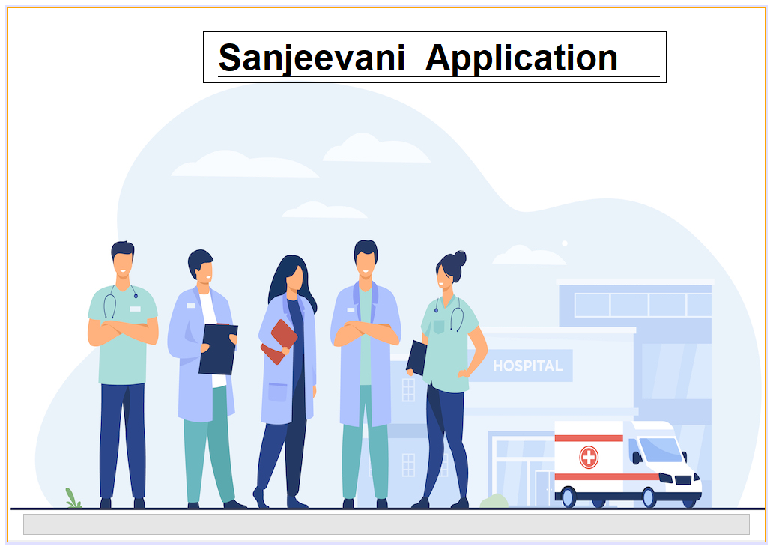

**Loading Screen**

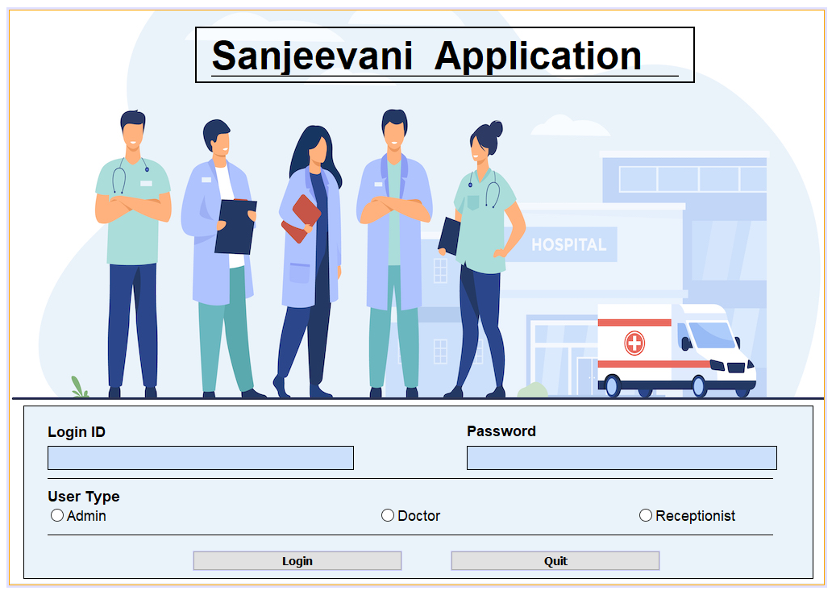

**LOGIN SCREEN**

**LOGIN SCREEN MODULE DESCRIPTION**

In this module, We will verify the user and redirect to the respective logged-in module(Admin Option module, Receptionist Option module, Doctor Option module).

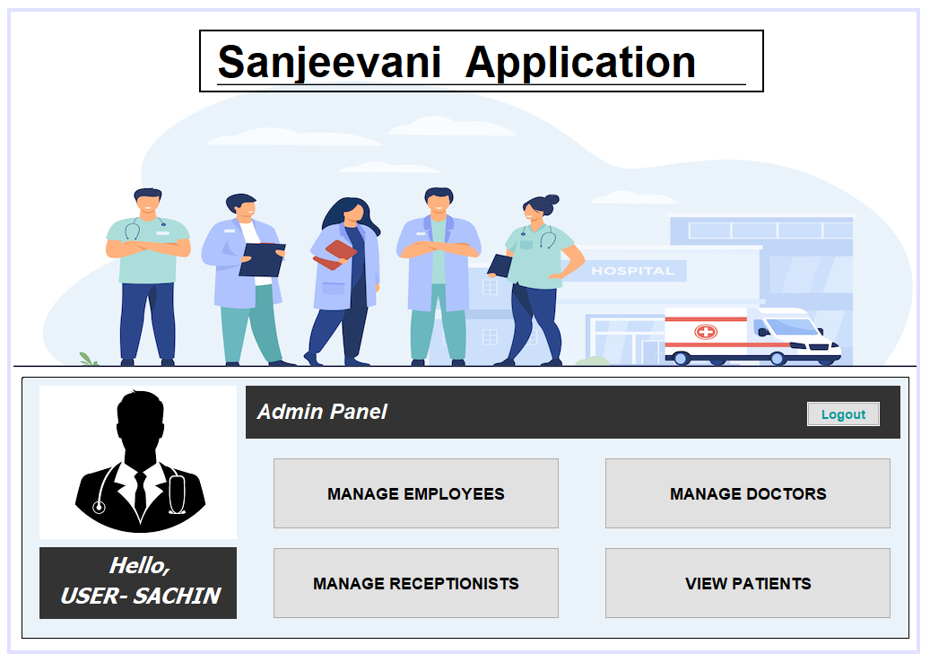

**ADMIN OPTION SCREEN**

**ADMIN OPTION SCREEN MODULE DESCRIPTION**

In this module, The admin can perform tasks like managing employees, managing doctors, managing receptionists, and viewing all the patients.

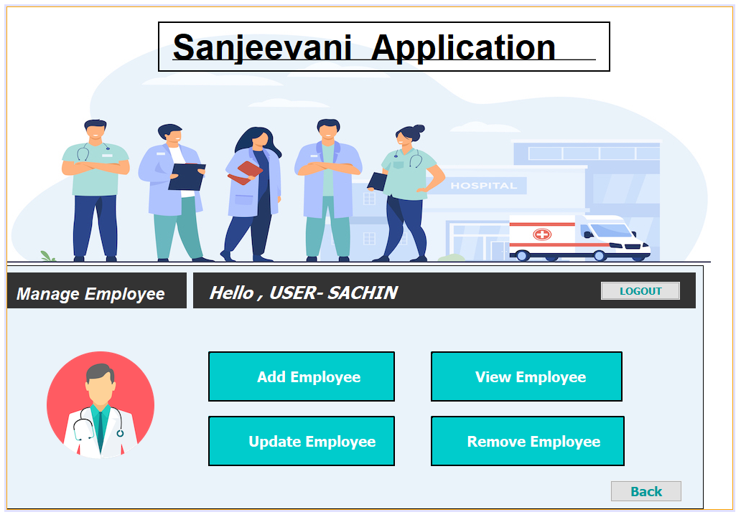

**MANAGE EMPLOYEE SCREEN**

**MANAGE EMPLOYEE SCREEN MODULE DESCRIPTION**

In this module, The admin can manage employees by adding new employees, updating existing employees, deleting/removing employees, and viewing all employee’s details.

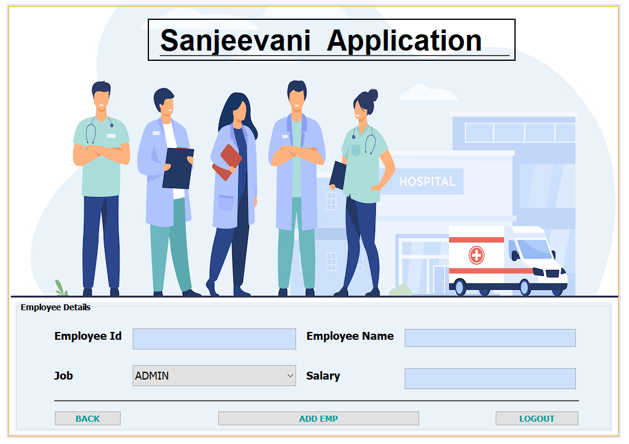

**ADD EMPLOYEE SCREEN**

**ADD EMPLOYEE SCREEN MODULE DESCRIPTION**

In this module, The admin will add the new employee by taking the details(employee’s name, employee’s department, employee’s salary) of that employee. The employee Id will be generated automatically for every employee.

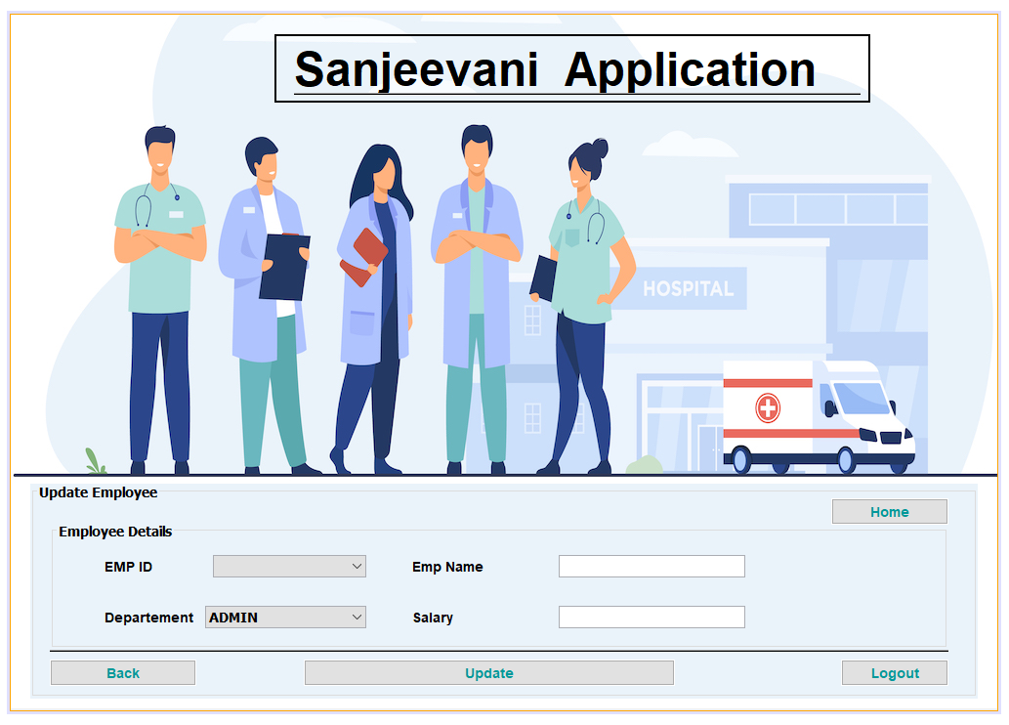

**UPDATE EMPLOYEE SCREEN**

**UPDATE EMPLOYEE SCREEN MODULE DESCRIPTION**

In this module, We will have a list of employee's id of all the employees through which we can explore all the employee's details to update or change the information.

The admin can update the existing employee whose previous details will be displayed.

Now the admin can update any information of the employee by taking the details(employee name, employee's department, employee salary) of that employee.

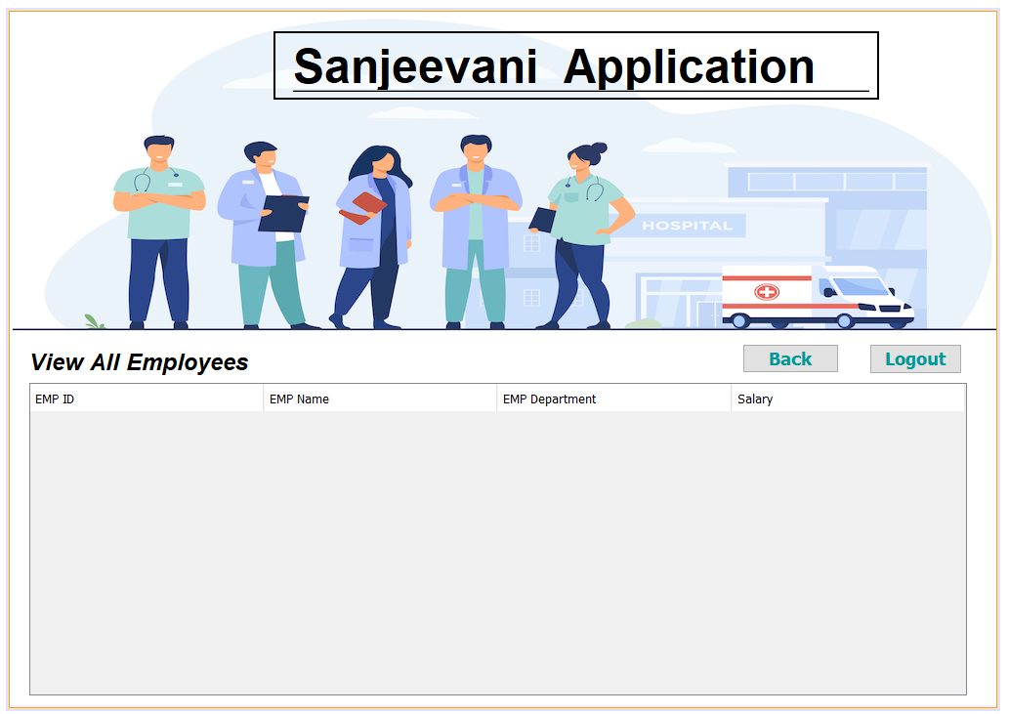

**VIEW ALL EMPLOYEE SCREEN**

**VIEW ALL EMPLOYEE SCREEN MODULE DESCRIPTION**

In this module, The admin can view all the employee details(employee name, employee's department, employee salary).

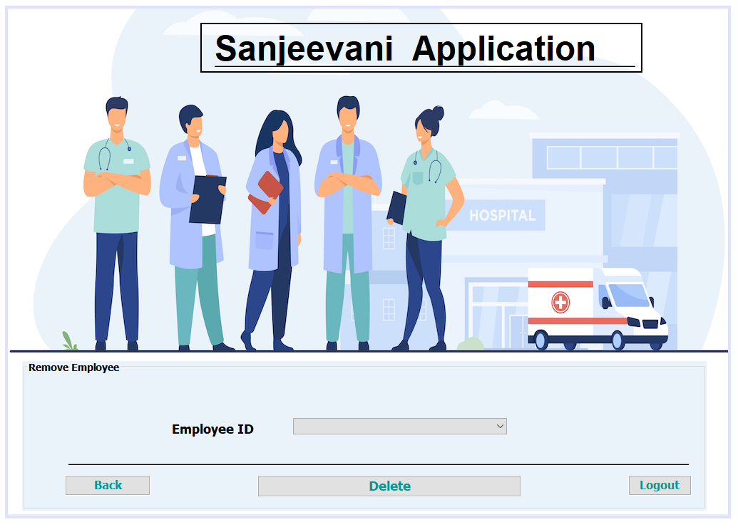

**REMOVE EMPLOYEE SCREEN**

**REMOVE EMPLOYEE SCREEN MODULE DESCRIPTION**

In this module, The admin can remove the employee with help of the given list of the employee's ids.

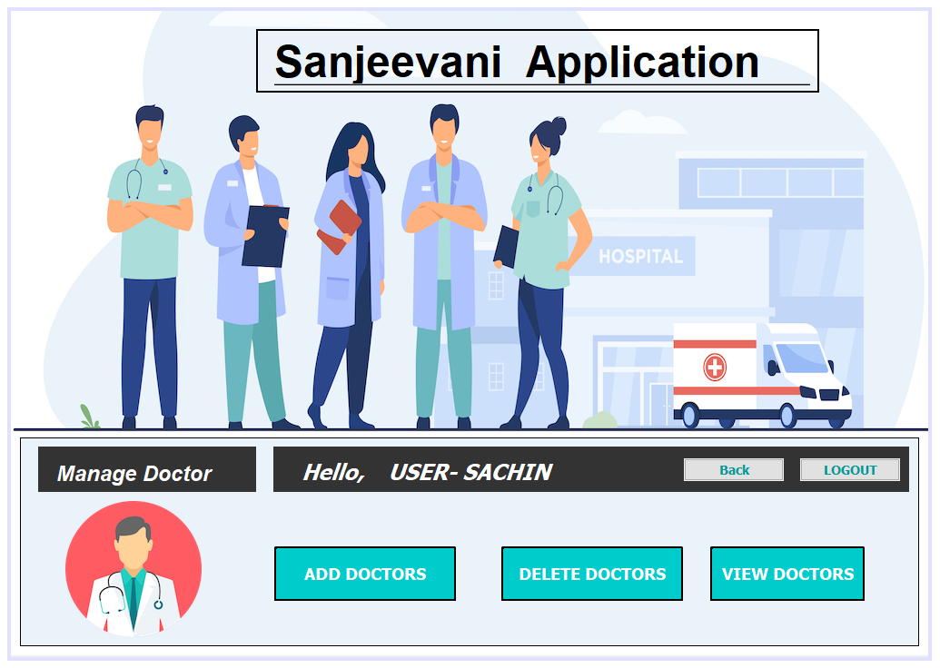

**MANAGE DOCTOR SCREEN**

**MANAGE DOCTOR SCREEN MODULE DESCRIPTION**

In this module, The admin can manage doctors by adding new doctors, deleting/removing doctors, and viewing all doctor’s details.

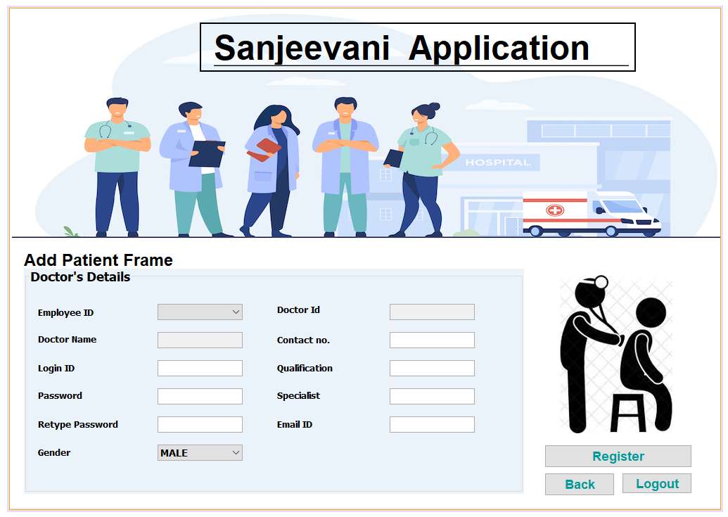

**REGISTER DOCTOR SCREEN**

**REGISTER DOCTOR SCREEN MODULE DESCRIPTION**

In this module, The admin will add the new doctors by taking the details of that doctor. The doctor Id will be generated automatically for every doctor.

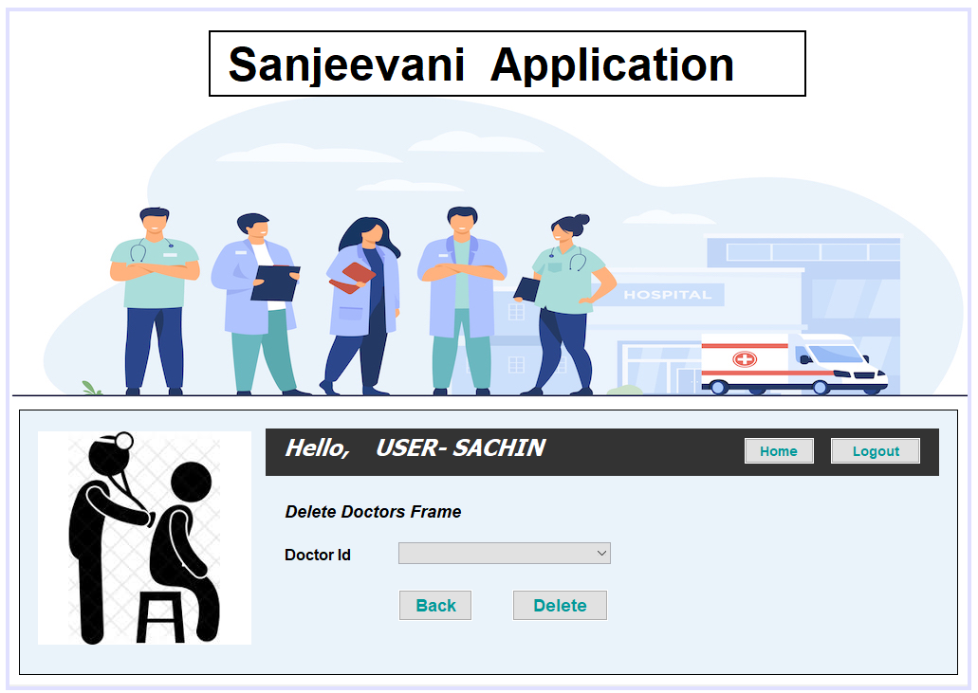

**REMOVE DOCTOR SCREEN**

**REMOVE DOCTOR SCREEN MODULE DESCRIPTION**

In this module, The admin can resign/fire the doctor from his position by the given list of the doctor's ids.

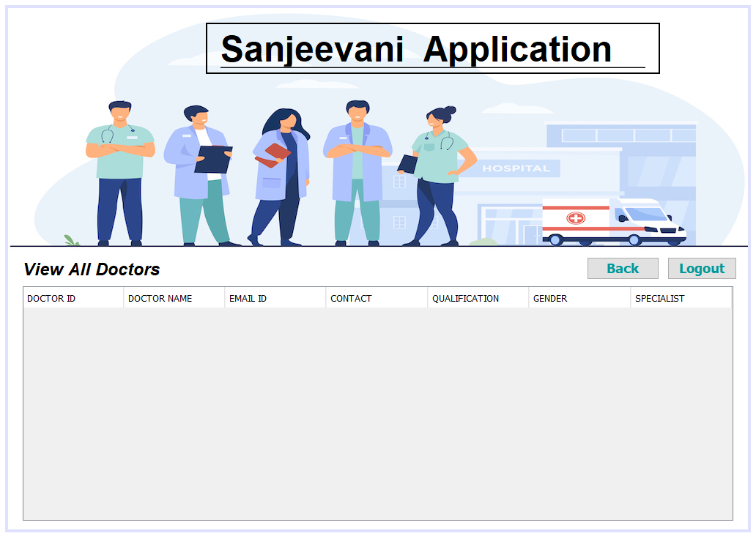

**VIEW ALL DOCTOR SCREEN**

**VIEW ALL DOCTOR SCREEN MODULE DESCRIPTION**

In this module, The admin can view all the doctor’s details.

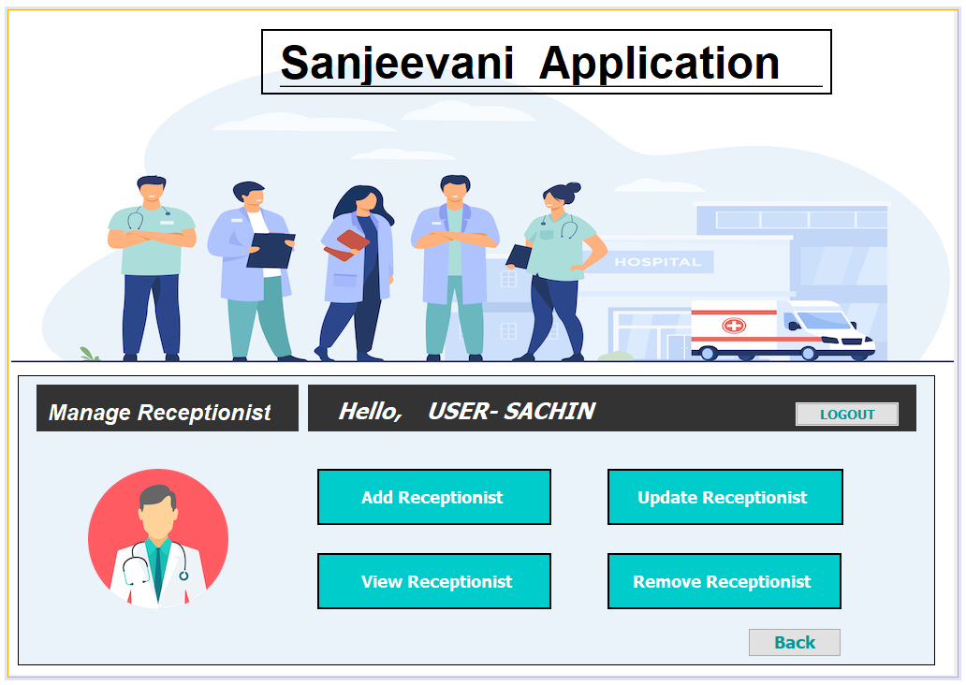

**MANAGE RECEPTIONIST SCREEN**

**MANAGE RECEPTIONIST SCREEN MODULE DESCRIPTION**

In this module, The admin can manage receptionists by adding new receptionists, updating existing receptionists, deleting/removing receptionists, and viewing all receptionist's details.

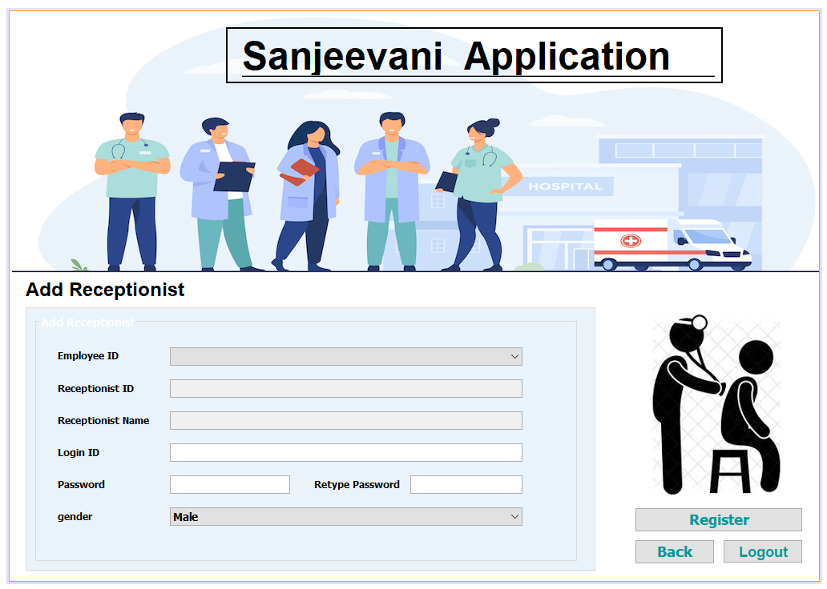

**ADD RECEPTIONIST SCREEN**

**ADD RECEPTIONIST SCREEN MODULE DESCRIPTION**

In this module, The admin will add the new receptionist by taking the details of that receptionist. The receptionist's Id will be generated automatically for every receptionist.

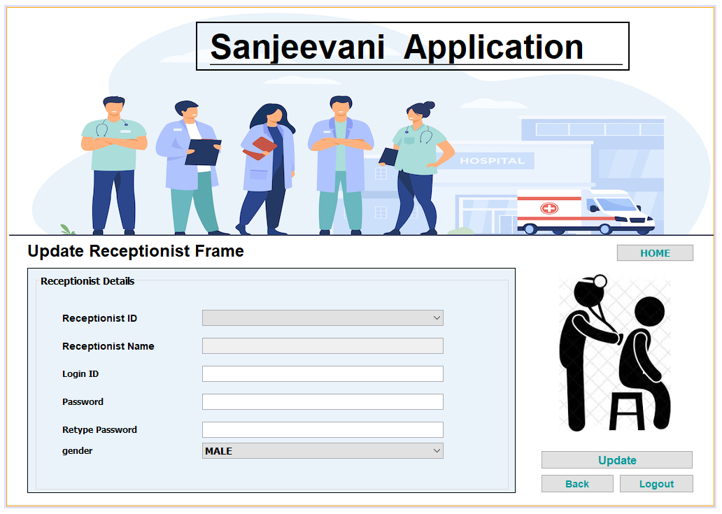

**UPDATE RECEPTIONIST SCREEN**

**UPDATE RECEPTIONIST SCREEN MODULE DESCRIPTION**

In this module, We will have a list of receptionist's id of all the receptionists through which we can explore all the receptionist details to update or change the information.

The admin can update the existing receptionist whose previous details will be displayed.

Now the admin can update any information about the receptionist by taking the details of that receptionist.

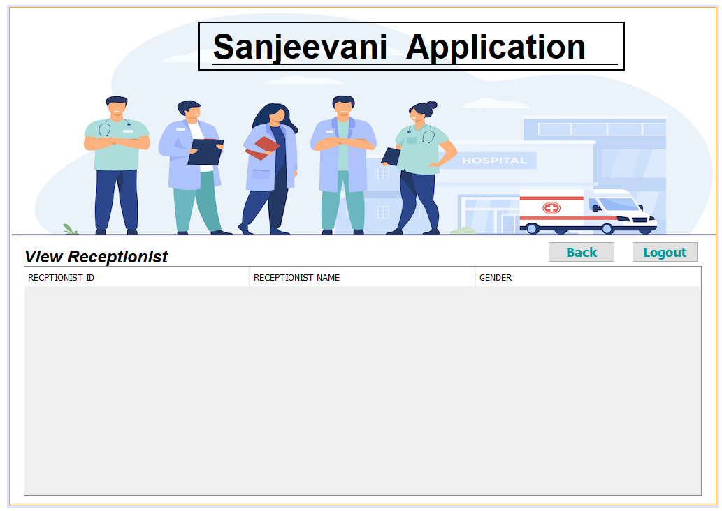

**VIEW ALL RECEPTIONIST SCREEN**

**VIEW ALL RECEPTIONIST SCREEN MODULE DESCRIPTION**

In this module, The admin can view all the details of the receptionist.

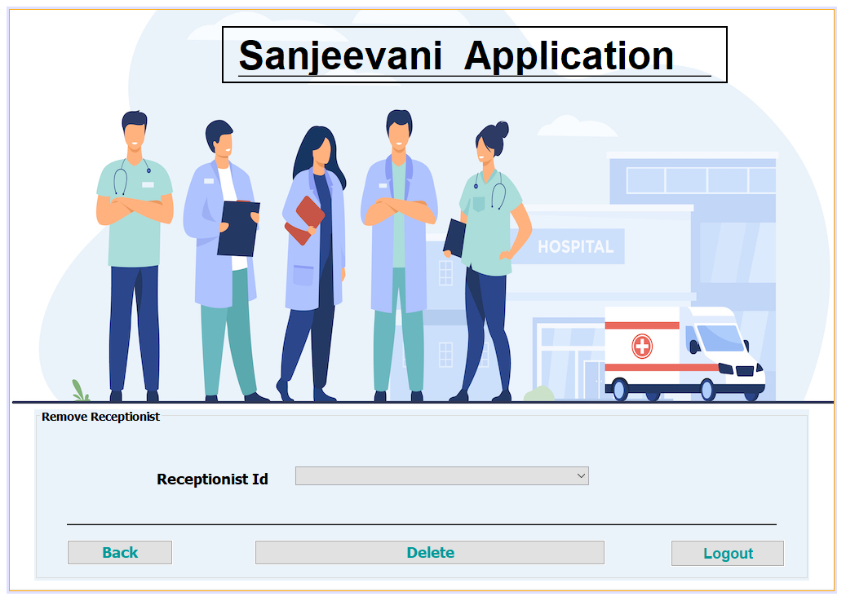

**REMOVE RECEPTIONIST SCREEN**

**REMOVE RECEPTIONIST SCREEN MODULE DESCRIPTION**

In this module, The admin can resign/fire the receptionist by the given list of the receptionist's ids.

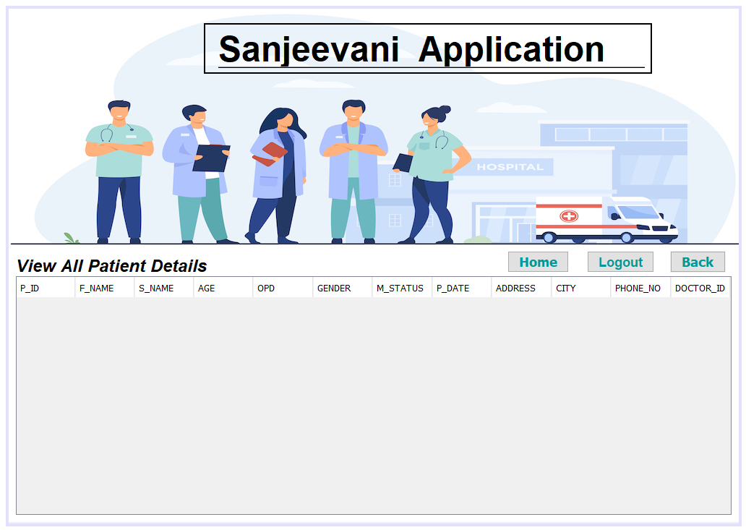

**VIEW ALL PATIENT DETAILS SCREEN**

**VIEW ALL PATIENT DETAILS SCREEN MODULE DESCRIPTION**

In this module, The admin can view all the patient details.

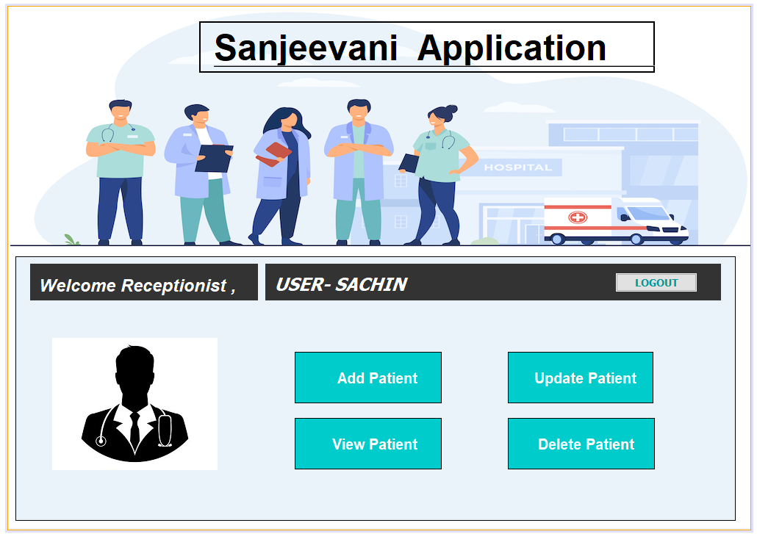

**RECEPTIONIST OPTION SCREEN**

**RECEPTIONIST OPTION SCREEN MODULE DESCRIPTION**

In this module, the receptionist will have four different functionality for managing the patient, which are adding the patient, updating the patient, discharging the patient, and viewing all the details of a single patient or all patient at once.

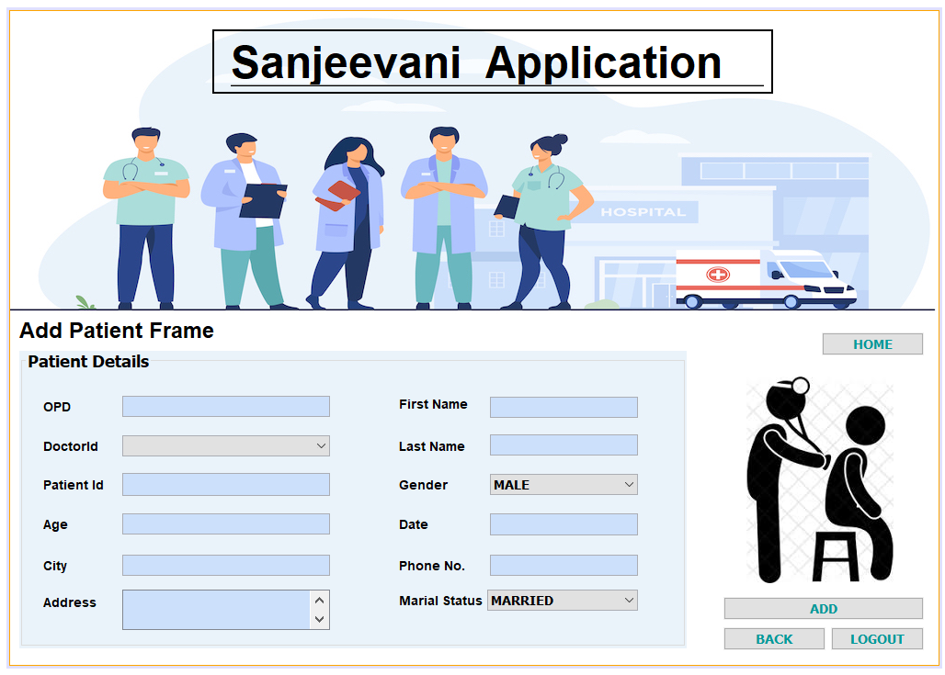

**ADD PATIENT SCREEN**

**ADD PATIENT SCREEN MODULE DESCRIPTION**

In this module, the receptionist will add the patient's details with auto-generated patient id. Now, these details will be redirected to the verified mobile number module.

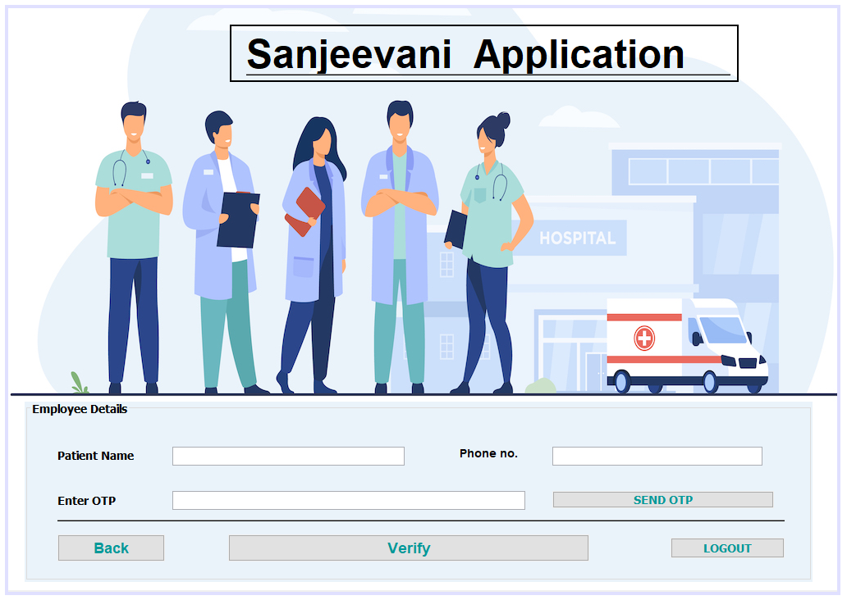

**VERIFY OTP SCREEN**

**VERIFY OTP SCREEN MODULE DESCRIPTION**

In this module, the receptionist will verify the mobile number of the patient by sending the OTP to the patient’s mobile number and the rest of the details will be auto-filled. Which can be modified. This appointment request will be send to the respected doctor id.

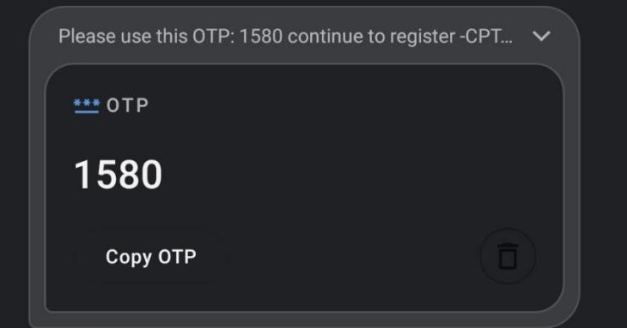

**OTP Confirmation Message**

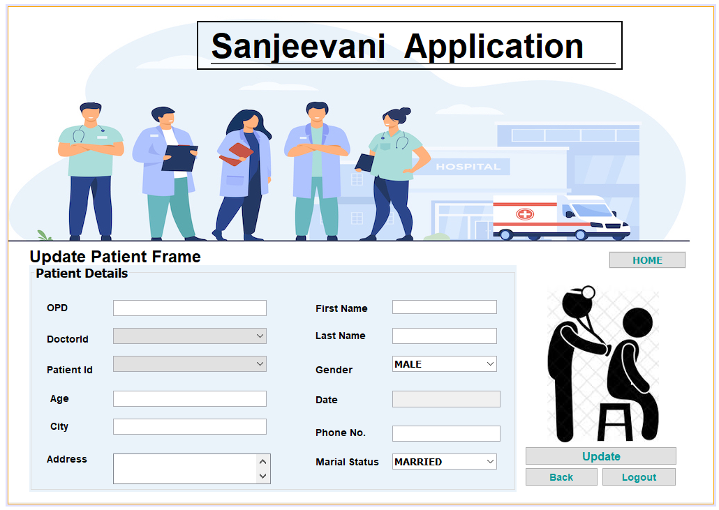

**UPDATE PATIENT SCREEN**

**UPDATE PATIENT SCREEN MODULE DESCRIPTION**

In this module, the receptionist will be able to update the information of the patient which will be auto-generated by the given list of patient ids.

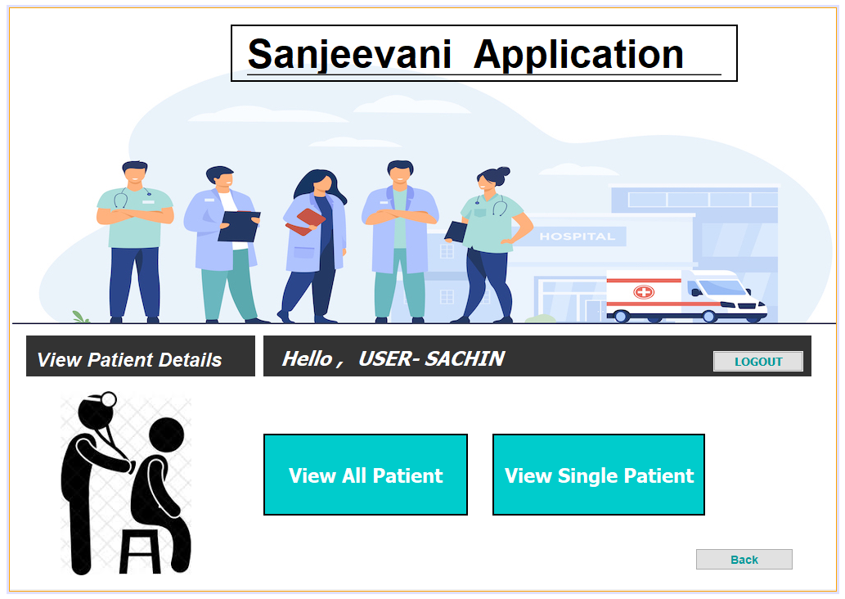

**VIEW ALL PATIENT DETAIL OPTION SCREEN**

**VIEW ALL PATIENT DETAIL OPTION SCREEN MODULE DESCRIPTION**

In this module, the receptionist will have two ways of viewing the details of the patient. The receptionist can either view all the patient's details at once or can view single patient detail.

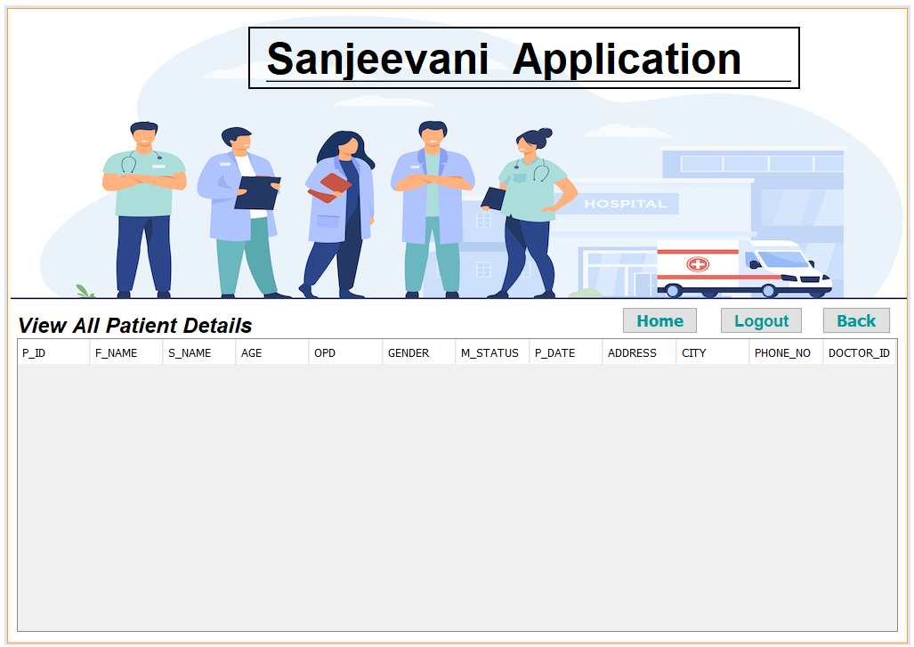

**VIEW ALL PATIENT DETAIL SCREEN**

**VIEW ALL PATIENT DETAIL SCREEN MODULE DESCRIPTION**

In this module, The receptionist can view all the patient’s detail at once.

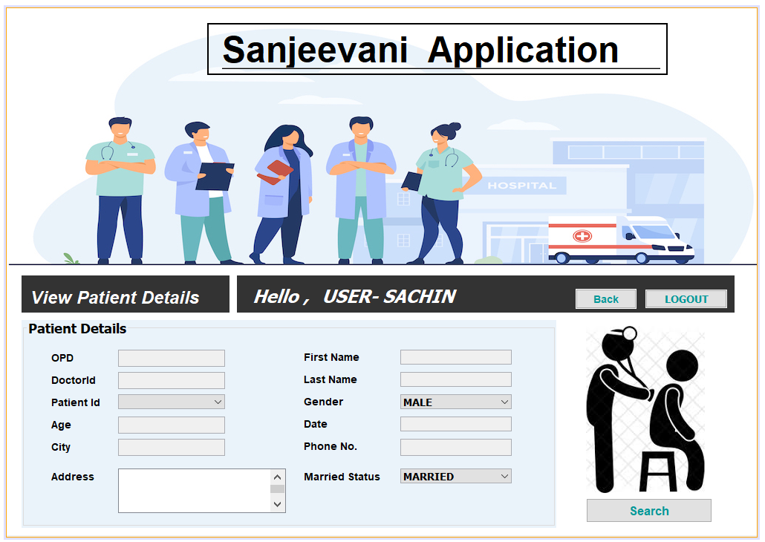

**VIEW SINGLE PATIENT DETAIL SCREEN**

**VIEW SINGLE PATIENT DETAIL SCREEN MODULE DESCRIPTION**

In this module, The receptionist can view all the patient’s details but once at a time by the given list of the patient id.

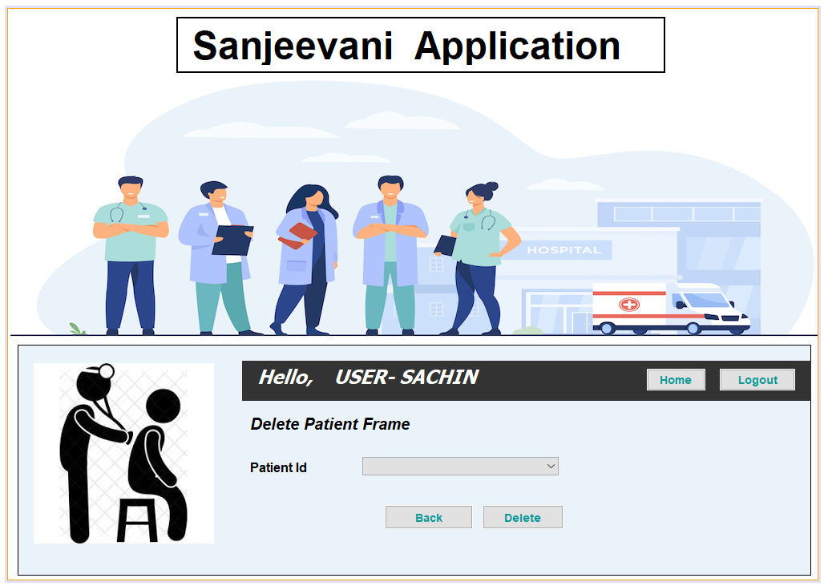

**REMOVE PATIENT SCREEN**

**REMOVE PATIENT SCREEN MODULE DESCRIPTION**

In this module, The receptionist can discharge the patient by the given list of the patient ids.

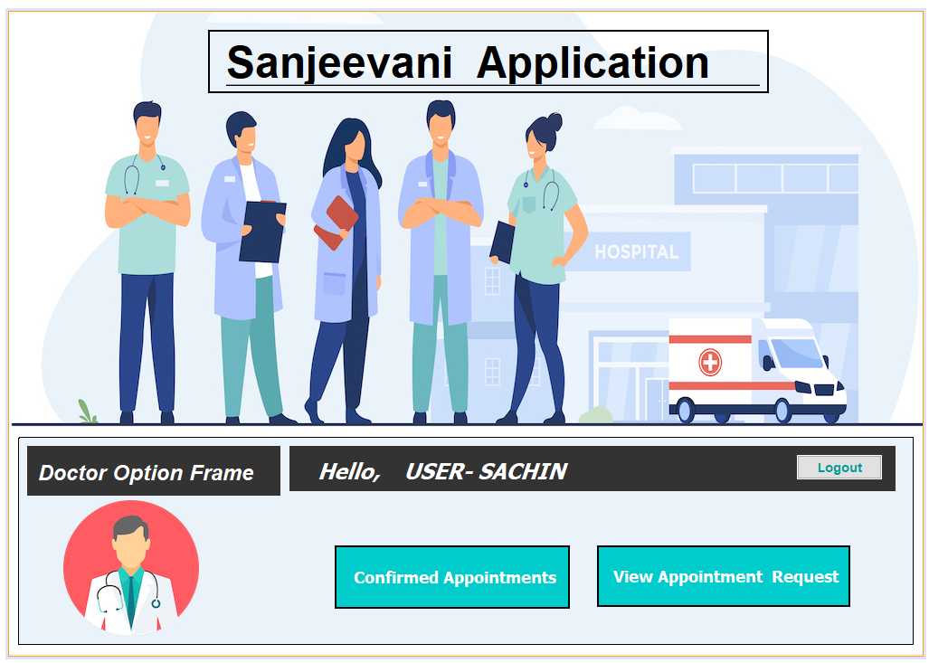

**DOCTOR OPTION SCREEN**

**DOCTOR OPTION SCREEN MODULE DESCRIPTION**

In this module, The doctor will have two different functionality to manage the patient’s appointment which are either the doctor can view the patient’s conformed appointment or the doctor can schedule the patient’s appointment request.

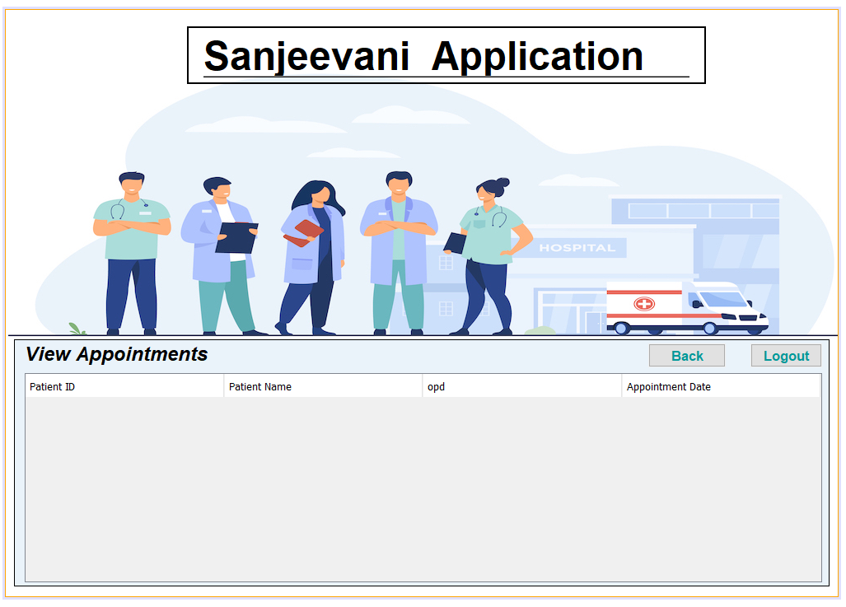

**APPOINTMENT REQUEST SCREEN**

**APPOINTMENT REQUEST SCREEN MODULE DESCRIPTION**

In this module, The doctor can view all the patient appointment’s request in the table. The doctor can click any of the patient appointment’s request and it will be redirected to the conform appointment module.

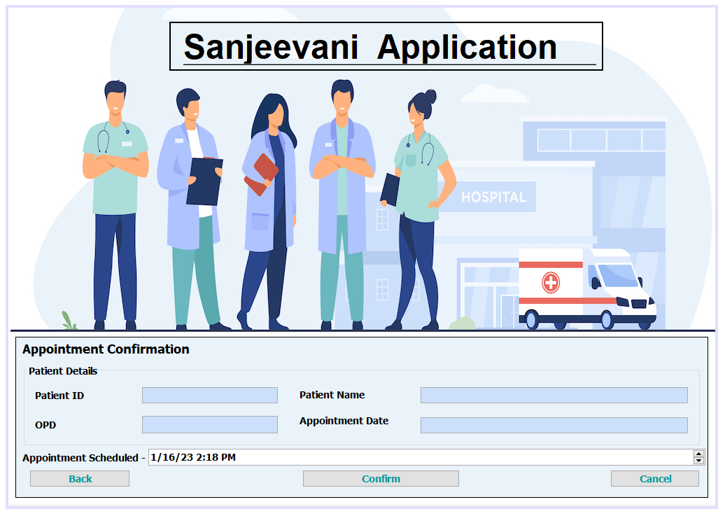

**CONFORM APPOINTMENT SCREEN**

**CONFORM APPOINTMENT SCREEN MODULE DESCRIPTION**

In this module, the doctor will schedule the patient appointment’s request. The patient’s detail will be auto-generated. After an appointment has been confirmed. The Appointment details of that patient will be sent to his mobile number.

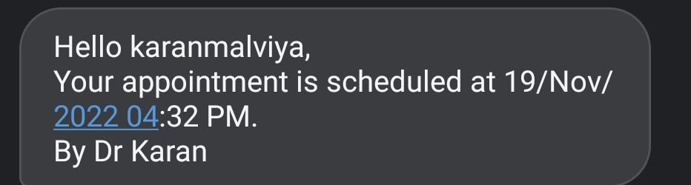

**Appointment Confirmation Message**

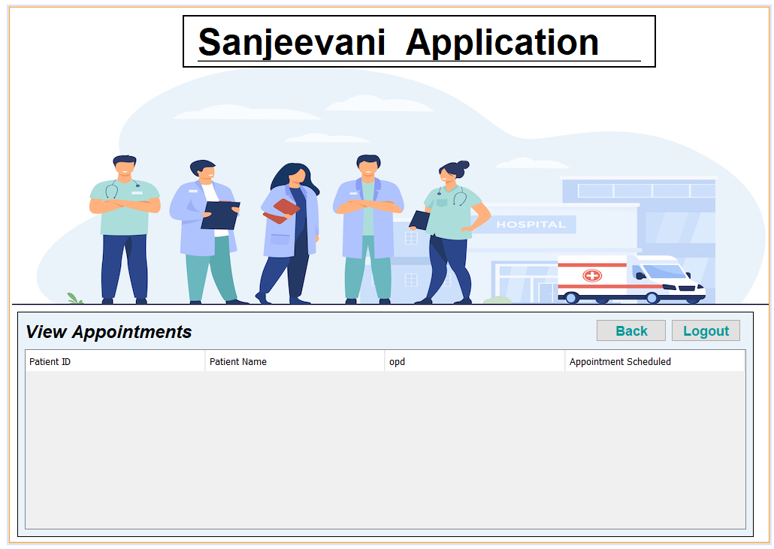

**VIEW ALL CONFORM APPOINTMENT SCREEN**

**VIEW ALL CONFORM APPOINTMENT SCREEN MODULE DESCRIPTION**

In this module, The doctor can view all the patient’s confirmed appointment.